C PROGRAMMING
NAME : VISHAAL G
REG NO : 1921260043
COURSE CODE : CSA0222
Task 4: Use Macros Safely (4 marks)
4.1 Safe macros
#define RUPEES_TO_PAISE(r) ((long)(r) * 100L)
#define SQUARE(x) ((x) * (x))
#define MAX(a, b) ((a) > (b) ? (a) : (b))
Parentheses protect the order of operations.
For example, the unsafe macro:
#define SQUARE(x) x*x
expands SQUARE(a + 1) into:
a + 1 * a + 1
For \(a=2\), this gives 5 instead of 9.
The safe macro expands to:
((a + 1) * (a + 1))
4.2 Why MAX can be dangerous
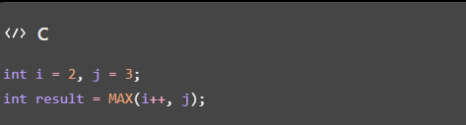
The argument i++ may be evaluated twice because the macro uses its argument in both the comparison and the selected expression. This can change the value of i unexpectedly.
Avoid side effects in macro arguments.
4.3 Preprocessor evidence
Save the program as macro.c and run:
gcc -E macro.c -o macro.i
The preprocessor expands macros and processes included headers. The expanded source is stored in macro.i.
4.4 Inline functions as an alternative
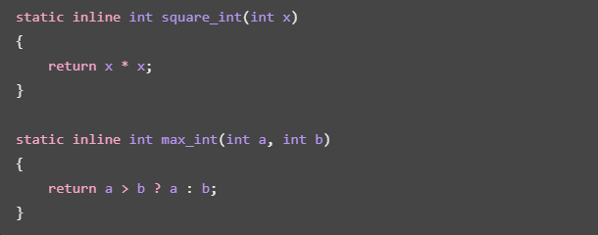
Inline functions evaluate each argument once and provide type checking. The compiler may inline them or generate normal function calls.
Both approaches can have \(O(1)\) time for these operations. A macro's expanded code may be repeated at each use, while an inline function may reduce duplicated code, depending on compiler optimization.

